**ASSIGNMENT 1**

**Task 1:** Create a Git repository named as your enrollment number. Create 2 folders in your repository named as Assignment_1 and Assignment_2.

**Step 1 :** Create Git Hub Account.

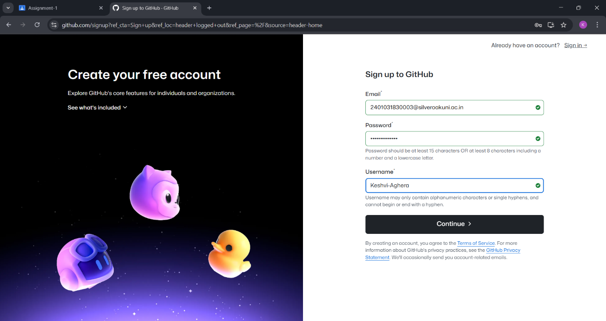

**Step 2 :** Create Repository.

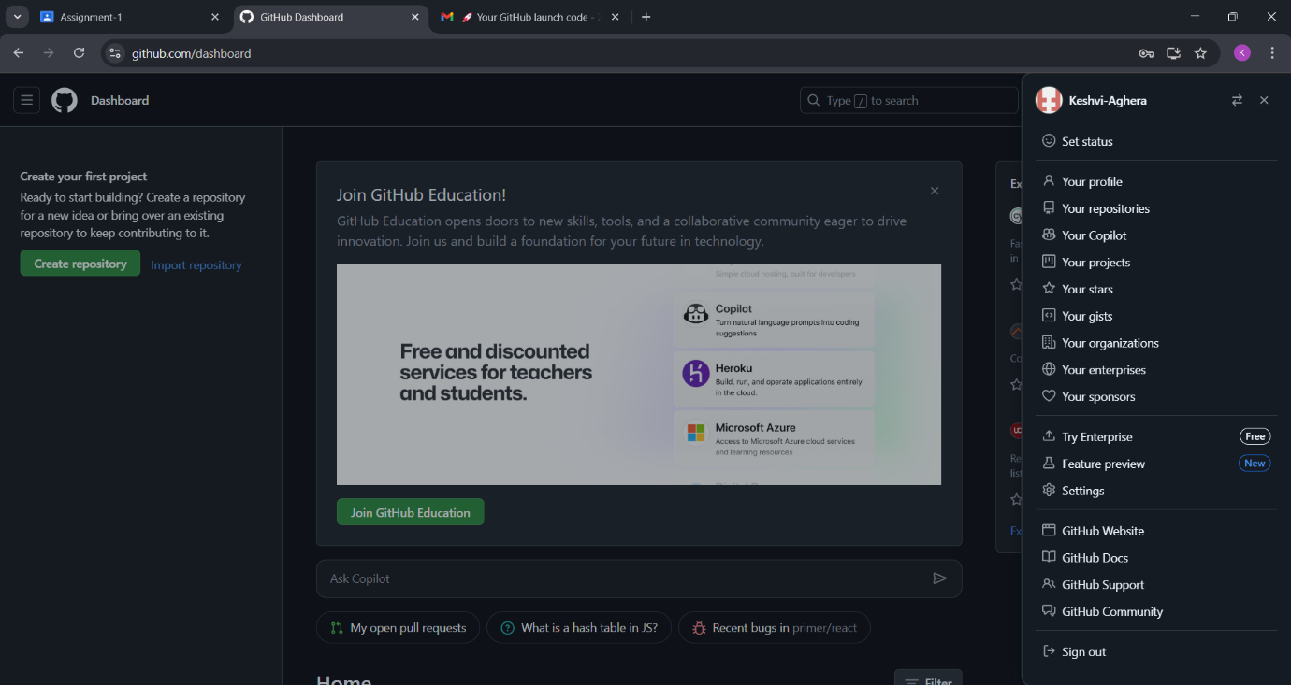

**Step 3 :** This Screen will appear after login now click on create repository to create repository ass per Enrollment no.

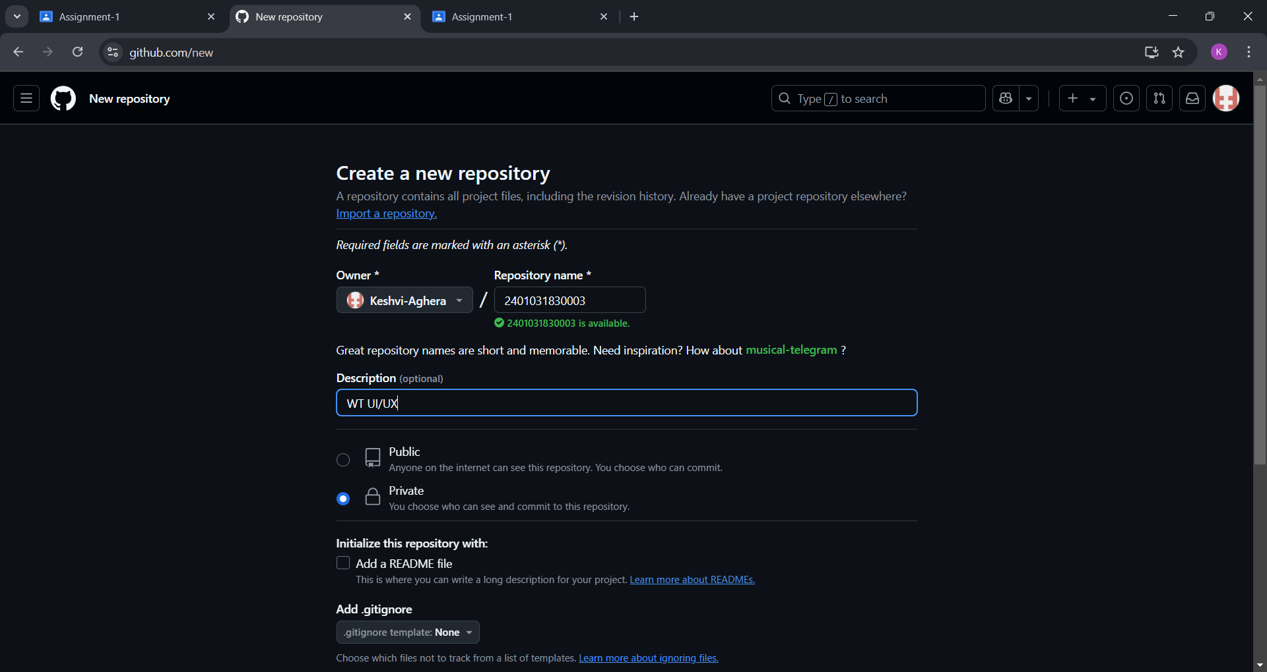

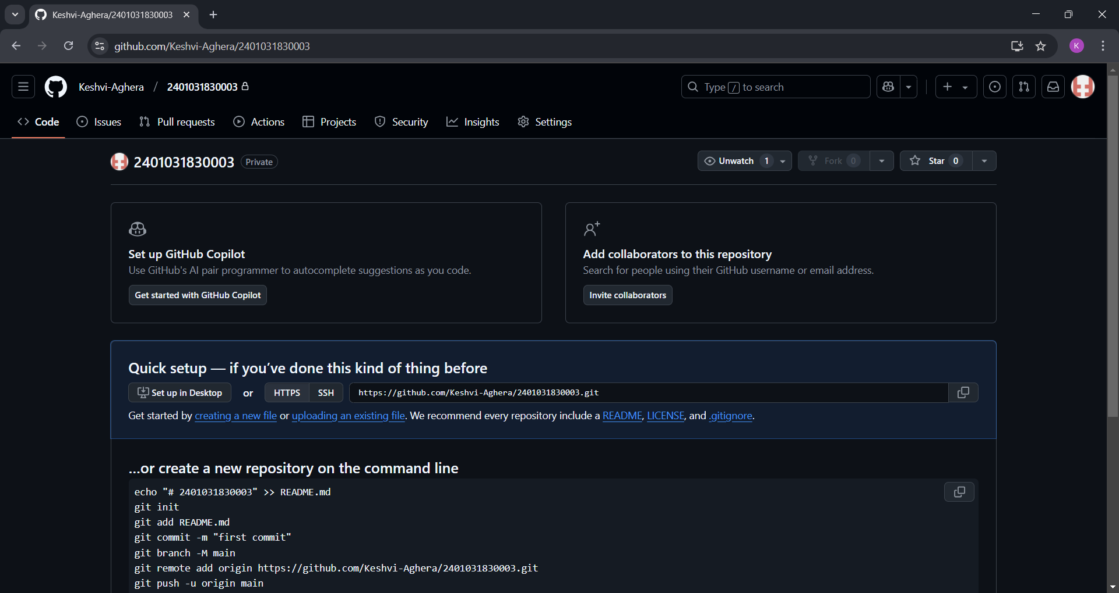

**Step 4 :** Create First folder named as Assignment_1 .

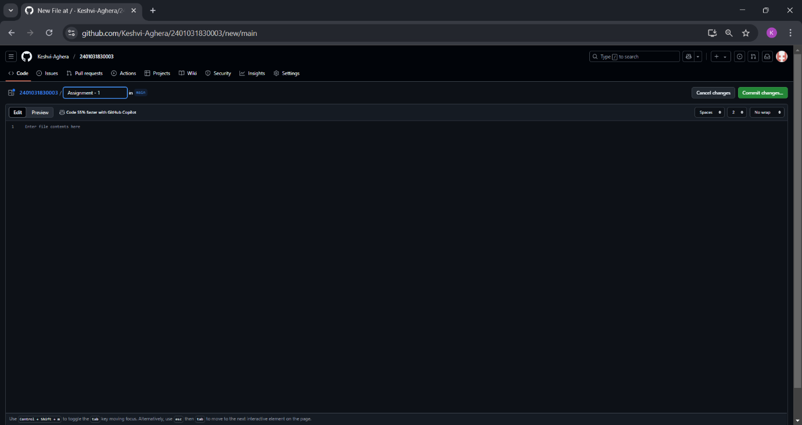

**Step 5:** Create another folder under Assignment-1 named Figma-Eco Friendly Lifestyle Hub and upload design photos.

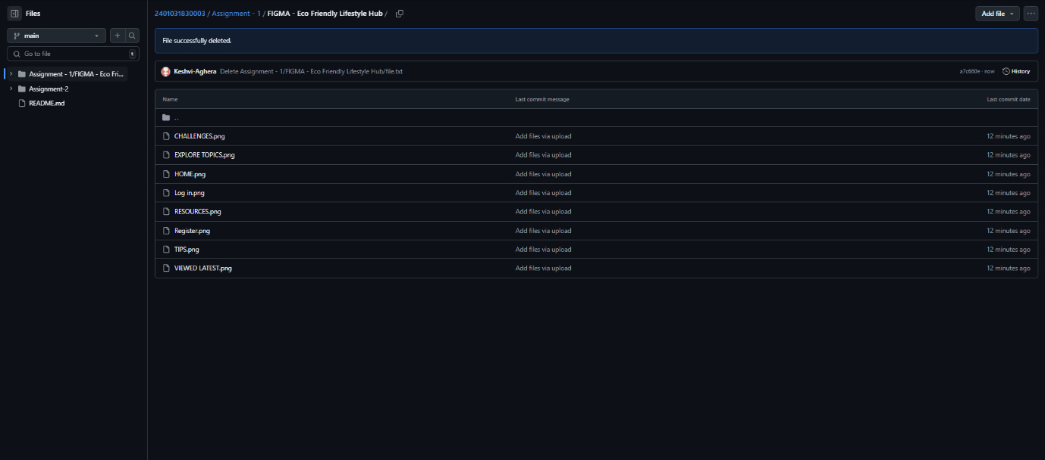

**Step 6 :** Create Second folder named as Assignment_2 and upload Document .

